Dear Business Owner,

We are writing to ask for your community support of A.K. Suter Elementary PTA. Our organization is dedicated to children's educational success, health, and well-being through strong family and community engagement. We provide many programs throughout the year, including:

FREE Book Fair Books for Every Student | Family Fun Night Events
Teacher/Classroom Grants | Faculty Appreciation Events
FREE Suter Fun Run Shirts for Every Student  School Improvements | Reflections Art Program  Accelerated Reader Program

We are requesting a sponsorship donation or in-kind donation of goods/services; no donation is considered too small. All sponsors will receive school wide recognition via social media coverage. We have included more information on our sponsorship levels. A.K. Suter Elementary PTA is a 501(c)(3) non-profit organization. Your donation may be fully tax deductible. We recommend you check with your accountant. Upon donation, our U.S. Tax ID number will be provided.

If you have any questions about our program or your donation, please contact Meg Perry at president@aksuterpta.org. Thank you for considering making a contribution to our program. We appreciate all of your efforts in the community.

Sincerely,

Meg Perry
PTA President
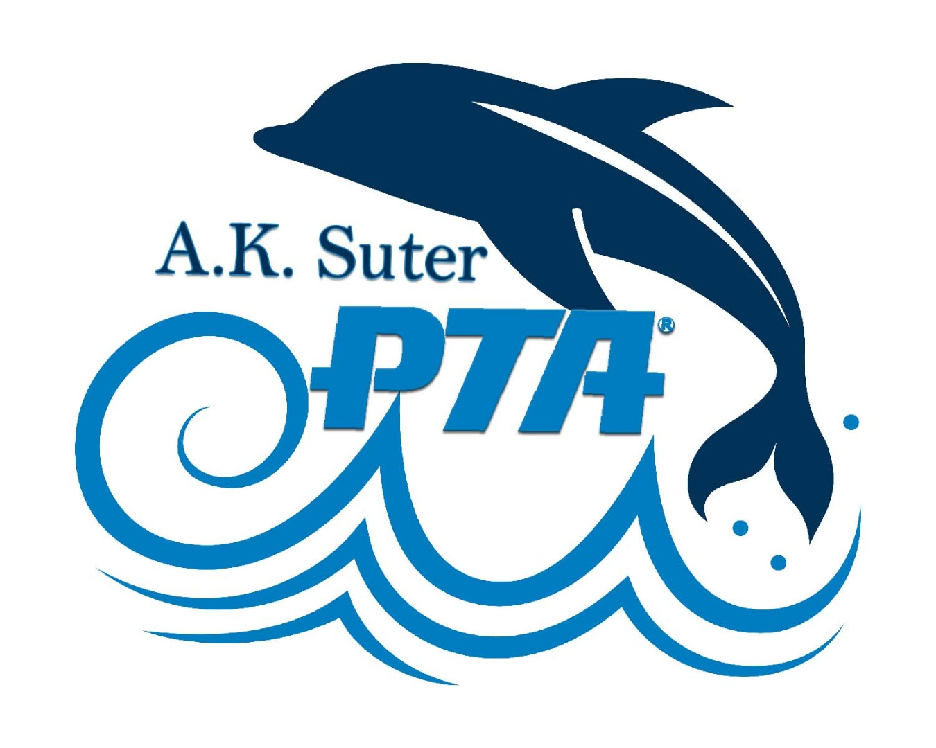
Please send completed Sponsorship Form (attached) and Donation to:

A.K. Suter Elementary PTA
c/o Caroline Brelsford - Treasurer
501 Pickens Ave.
Pensacola, FL 32503

