Student Instructions for Logging into Mental Health 360

Step 1:
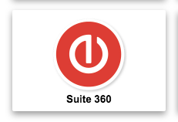
Go to the district website escambiaschools.org and click on the Core App Dashboard under quick links on the right-hand side of the screen.
Step 2:
Click the Suite 360 link button.

Step 3:
Sign in with your Novell password. Novell username (student number) and default password* (Pw six digit birthdate EX: Pw011805). *Unless you have modified your password. If you need password help please reach out to your Academic advisor.
Step 4:
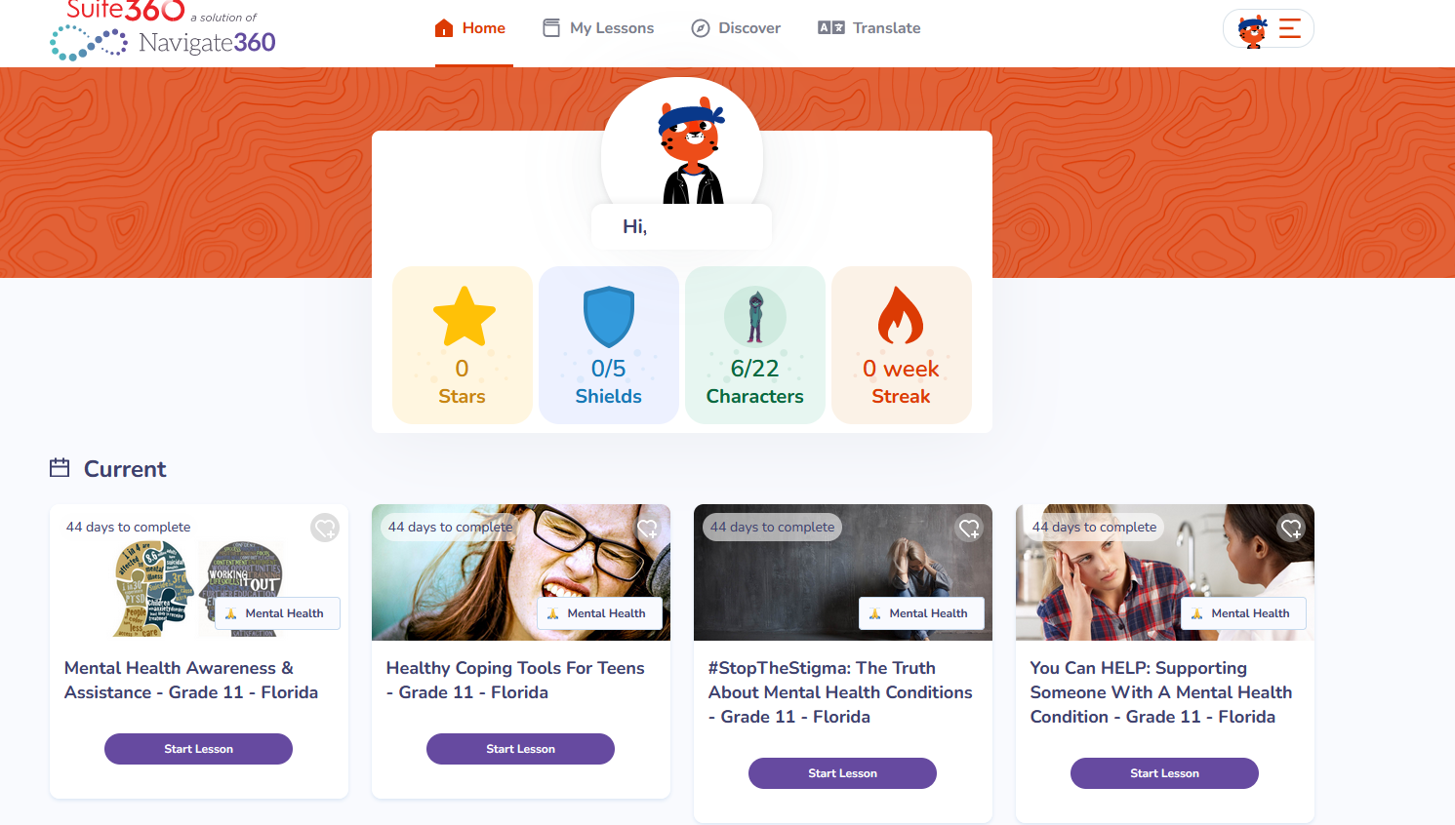
Step 5: Click START LESSON to begin each lesson. Two lessons should be completed each week, however, all lessons are open for access and can be completed immediately. Students must pass the lesson quiz with a 50% or higher to move forward. All lessons and assignments must be completed by September 30. Please note topic titles vary by grade level and are required on a yearly basis.
Lesson 1: Mental health disorders signs and symptoms Lesson 5: Strategies for Support
Lesson 2: Mental health disorders prevention Lesson 6: Suicide Prevention
Lesson 3: Awareness of local and community resources Lesson 7: Drug Abuse and Addiction
Lesson 4: Strategies for coping techniques Lesson 8: Child Trafficking/Substance Abuse Prevention

