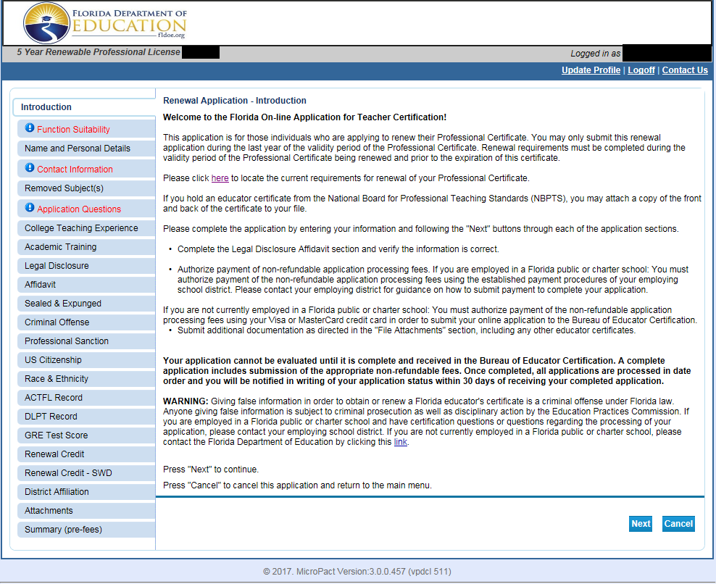
1. Introduction Page
Please review important information about the following:
- Application Type;
- Requirements for Renewal;
- Legal Disclosure;
- Submission of Payment;
- Processing Timeline; and
- Warning about false information.
Click Next to proceed to the next page.
If this application is the incorrect application, you may select Cancel to return to the main menu.

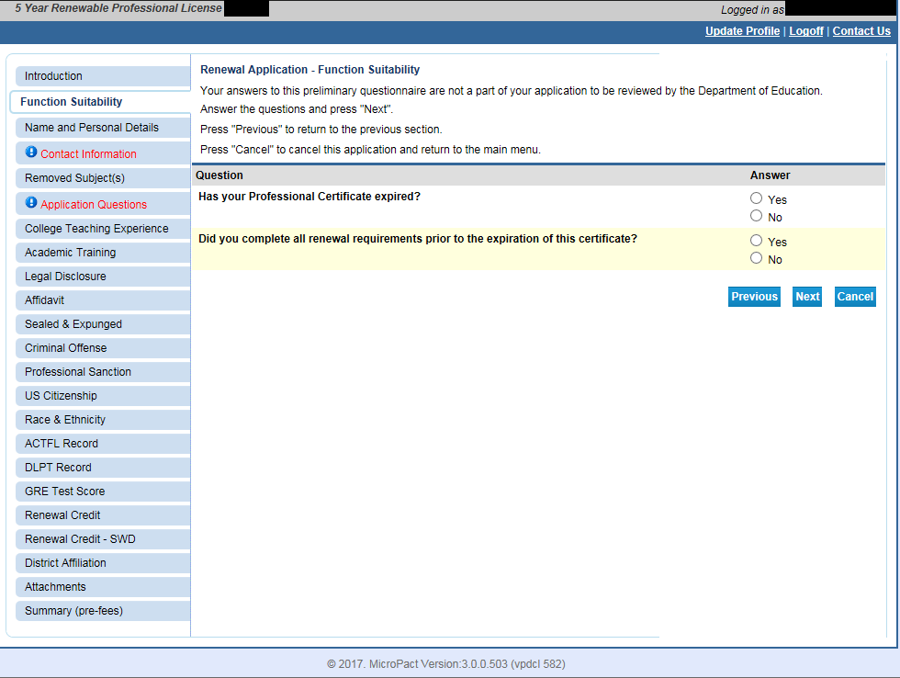

2. Function Suitability Questions
Respond to the following three questions to determine if you are completing the correct application:
 | Response
Question | Yes | No
Has your Professional Certificate Expired? | Error. The system will not allow you to proceed if you do not hold a valid certificate. | Answer “no” if your Professional Certificate is valid at the time that you complete the application.
Did you complete all renewal requirements prior to the expiration of this certificate? | You must answer yes to complete the application. | At this time, the system will not allow you to continue if you answer “no to this question.

Click Next to proceed to the next page.

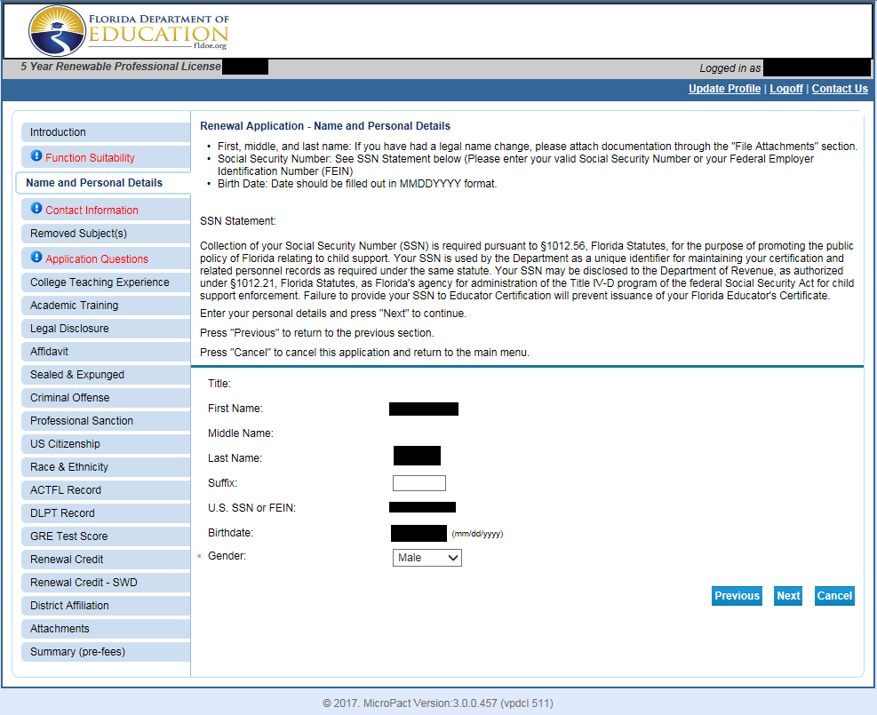
3. Name and Personal Details
Review information and verify if it is correct. You may update the selection for gender.
If the information is incorrect:
- contact your employing district office, or
- contact the Bureau of Educator Certification if you are employed by a private school organization or you are not currently employed as an educator.
Per the instructions provided, please attach documentation of your legal name change through the Attachments section at the end of the application.
Click Next to proceed to the next page.

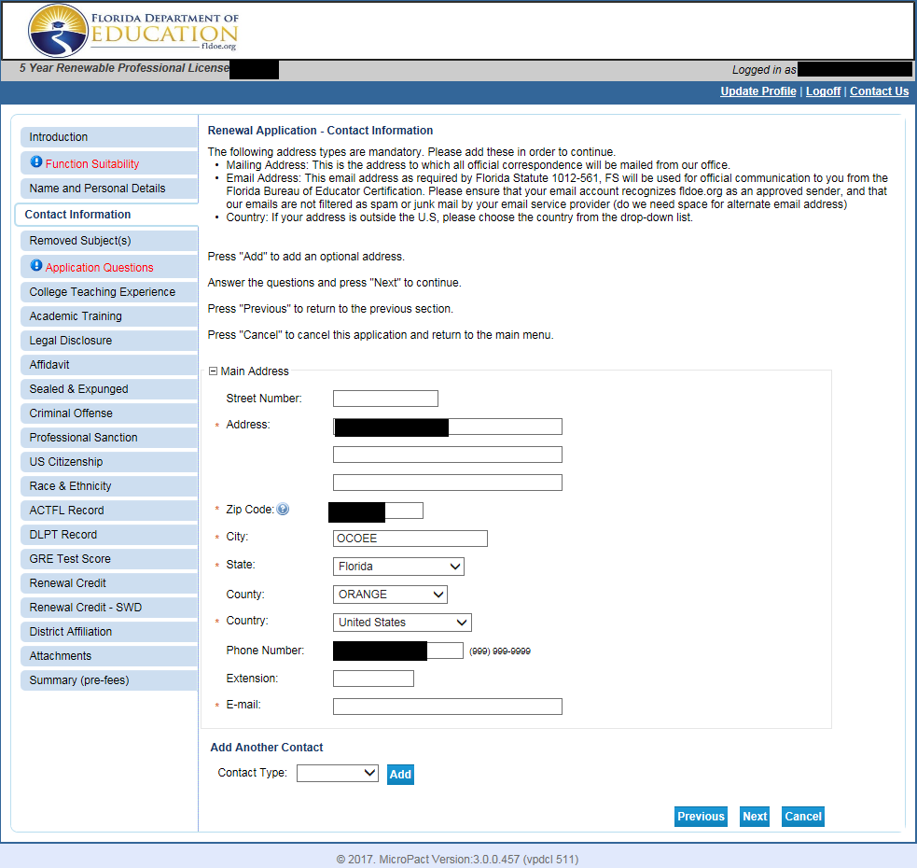
4. Contact Information
Please review the mailing address and email address on file with the Bureau of Educator Certification. If you need to make changes, please edit the fields.
You may add an additional contact information record by clicking Add.
Note: We recommend the use of a personal email account. Some district email servers prevent the receipt of automated emails.
Click Next to proceed to the next page.

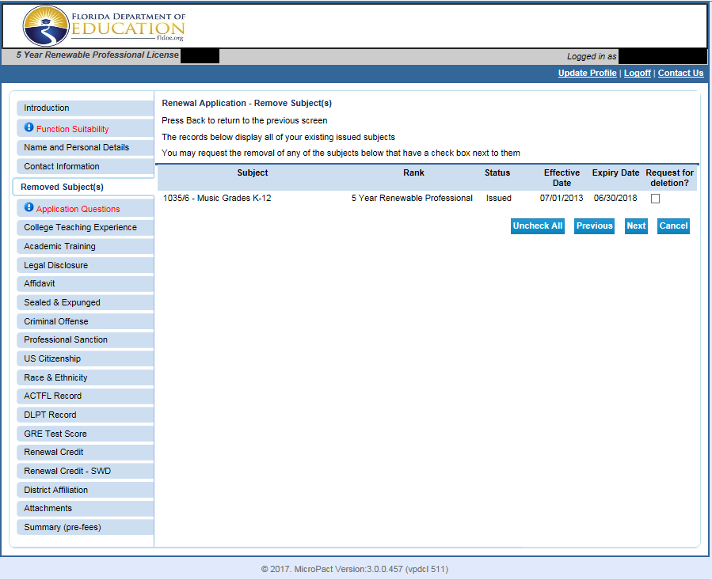
5. Remove Subject(s)
This page lists the subject(s) currently on your professional certificate.
IMPORTANT: PLEASE READ CAREFULLY
If you are not removing subject coverages on your certificate: | If you are requesting the removal of subject coverage(s) currently on your certificate:
Click Next to proceed to the next page. | Select the checkbox next to the subject.  Please contact your district for local policies regarding the deletion of subjects.  Click Next to proceed to the next page.

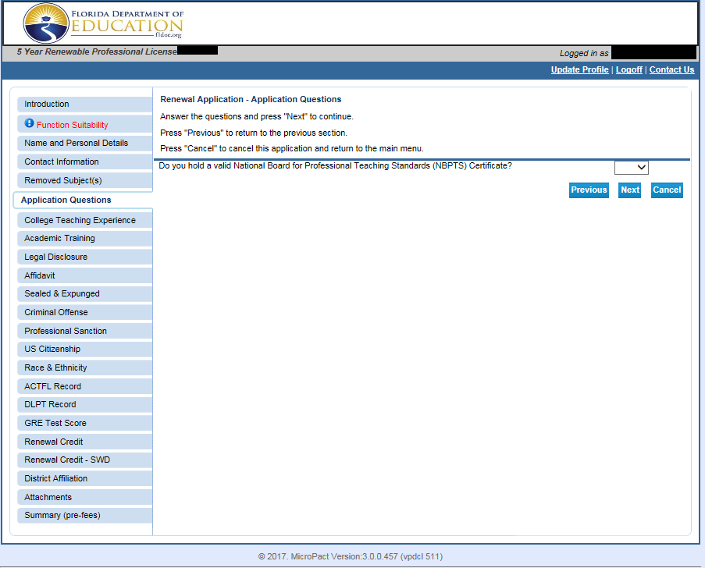
6. Application Questions
Indicate if you hold a National Board for Professional Teaching Standards (NBPTS) certificate.
Select Yes or No from the drop down menu.
NOTE: If you select Yes, please submit a copy of your certificate in the Attachments section.
Click Next to proceed to the next page.

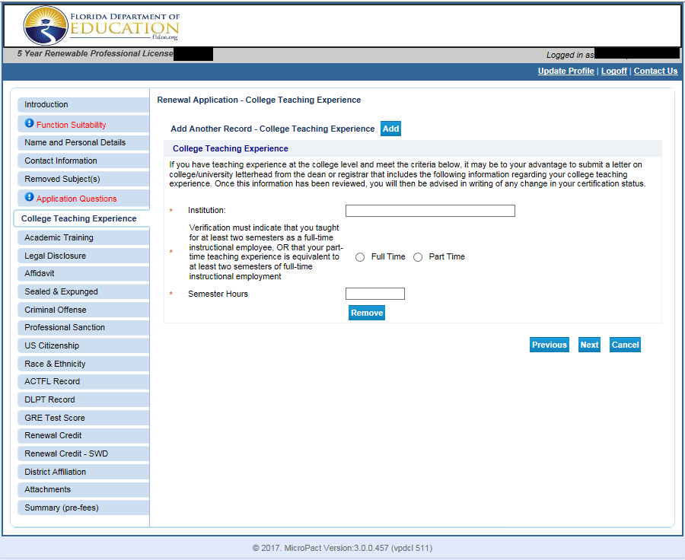
7. College Teaching Experience
If you do not have college teaching experience: | If you have college teaching experience:
Click Next to proceed to the next page. | Click Add to enter a new record to display the fields above.  Enter the name of the institution.  Select the correct radio button for Full-time or Part-time.  Enter the number of semester hours earned by students taking the course.  Provide a verification letter per the instructions on the page. You can upload the letter in the Attachments section at the end of the application.  Click Next to proceed to the next page.
If you accidentally click the “add” button:
Click Remove.

Click Ok to confirm that you want to delete the record, and then click Next to proceed to the next page.
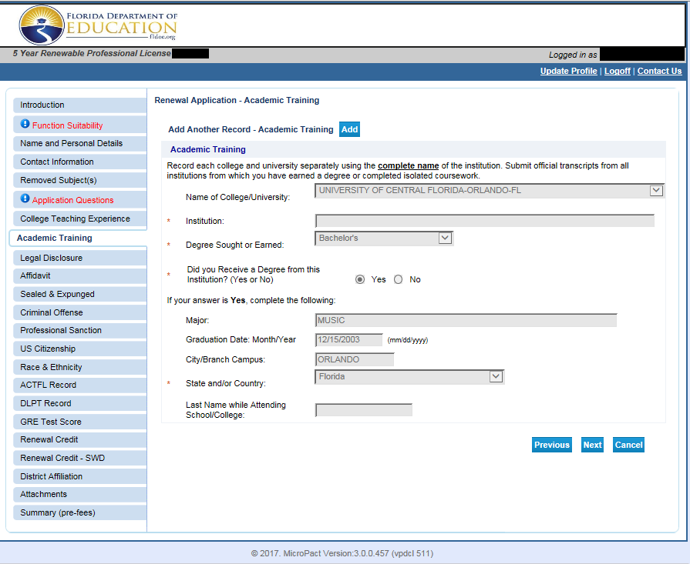
8. Academic Training
This screen includes information about the institutions where you earned your degrees or took post-secondary coursework.
Your information may be populated based on transcript(s) that you submitted to us. Pre-populated information cannot be updated (as seen in the above screenshot).
You will not need to submit any official transcripts already on file. Please only submit official transcripts since your last certification application.
If the information is not populated, please enter information for ALL fields.
Click Add to submit additional information about your academic training.
NOTE: Entering this information does not replace an official transcript.
Click Next to proceed to the next page.
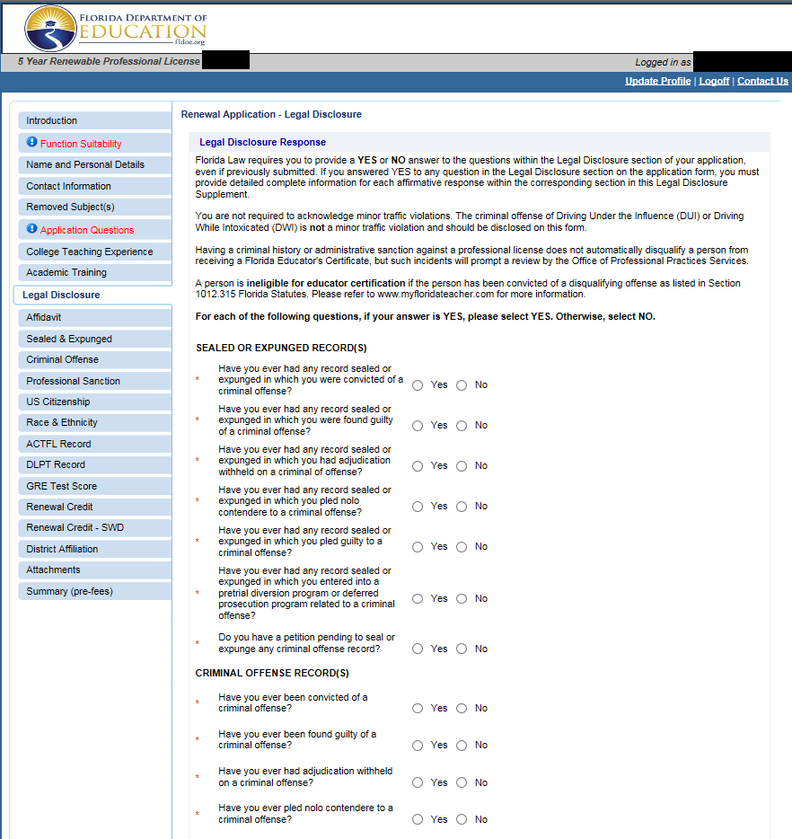
9. Legal Disclosure
For each of the following questions, if your answer is YES, please select YES. Otherwise, select NO. Carefully review instructions on this screen.
Florida Law requires you to provide a YES or NO answer to the questions within the Legal Disclosure section of your application, even if previously submitted.
If you answered YES to any question in the Legal Disclosure section on the application form, you must provide detailed complete information for each affirmative response within the corresponding section in this Legal Disclosure Supplement.
Click Next to proceed to the next page.

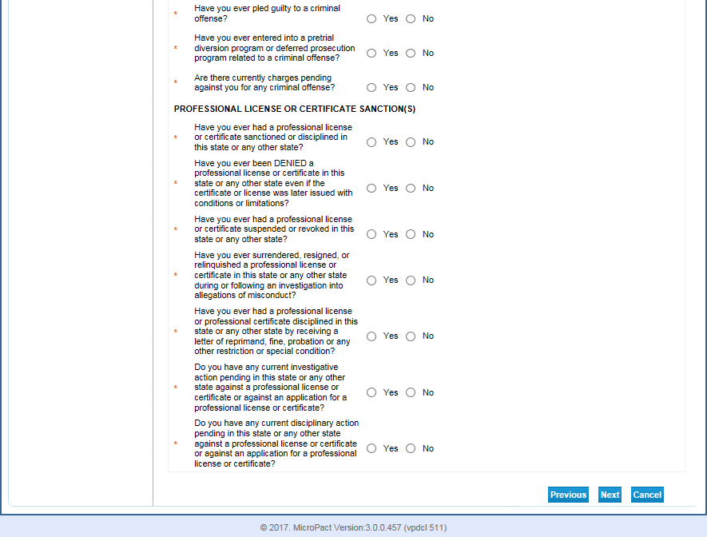
9. Legal Disclosure (continued)
For each of the following questions, if your answer is YES, please select YES. Otherwise, select NO.
Carefully review instructions on this screen.
Florida Law requires you to provide a YES or NO answer to the questions within the Legal Disclosure section of your application, even if previously submitted.
If you answered YES to any question in the Legal Disclosure section on the application form, you must provide detailed complete information for each affirmative response within the corresponding section in this Legal Disclosure Supplement.
Click Next to proceed to the next page.

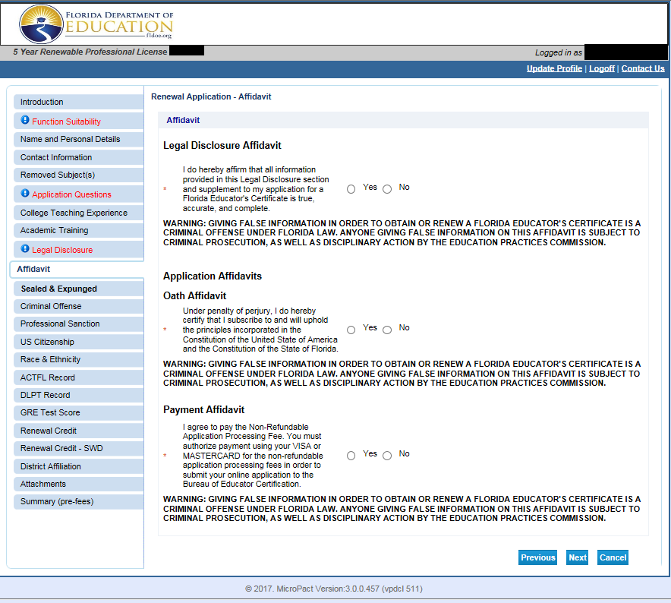10. Legal Disclosure Affidavit and Application Affidavits
Legal Disclosure Affidavit | Oath Affidavit | Payment Affidavit
Select Yes or No to affirm that all information provided in this Legal Disclosure section and supplement to my application for a Florida Educator's Certificate is true, accurate, and complete. | Select Yes or No to certify that you will subscribe to and will uphold the principles incorporated in the Constitution of the United State of America and the Constitution of the State of Florida. | Select Yes or No to agree to pay the Non-Refundable Application Processing Fee. You must authorize payment using your VISA or MASTERCARD for the non-refundable application processing fees in order to submit your online application to the Bureau of Educator Certification.  NOTE: If you are employed by a school district (including charter schools), select Yes and contact your employer to arrange payment. You are not required to use a Visa or Mastercard.
Click Next to proceed to the next page.
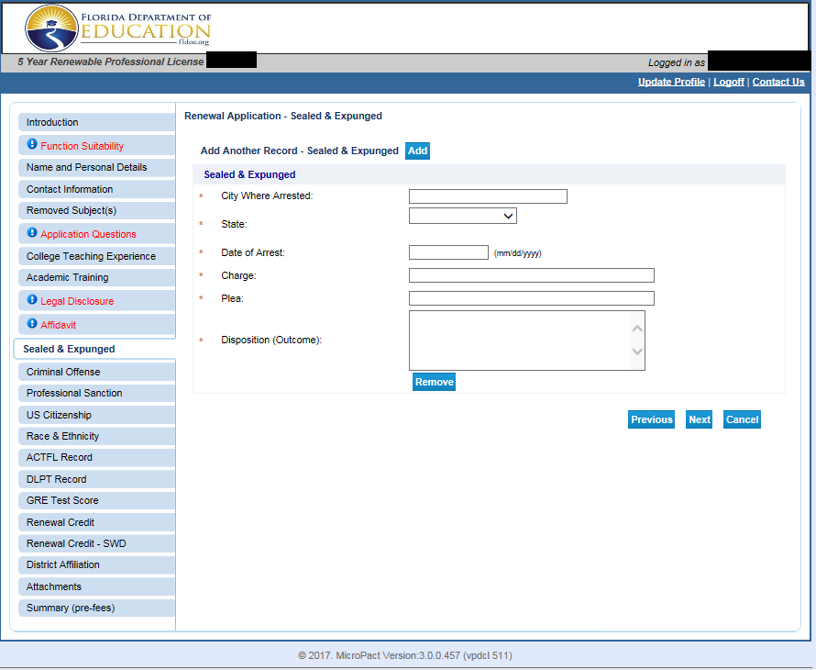
11. Sealed and Expunged
Carefully review instructions on the Legal Disclosure screen (see pages 9 and 10).
If you answered YES to any question in the Sealed and Expunged section of the Legal Disclosure on the application form: | If you answered NO to any question relating to Sealed and Expunged records:
You must provide detailed complete information for each affirmative response within the Sealed and Expunged section in this Legal Disclosure Supplement.  Click Add to enter a new record to display the fields above.  Enter information for all required fields.  Click Add to enter additional record(s).  Click Next to proceed to the next page. | Click Next to proceed to the next page.
 | If you click the “add” button in error:
Click Remove.

Click Ok to confirm that you want to delete the record, and then click Next to proceed to the next page.
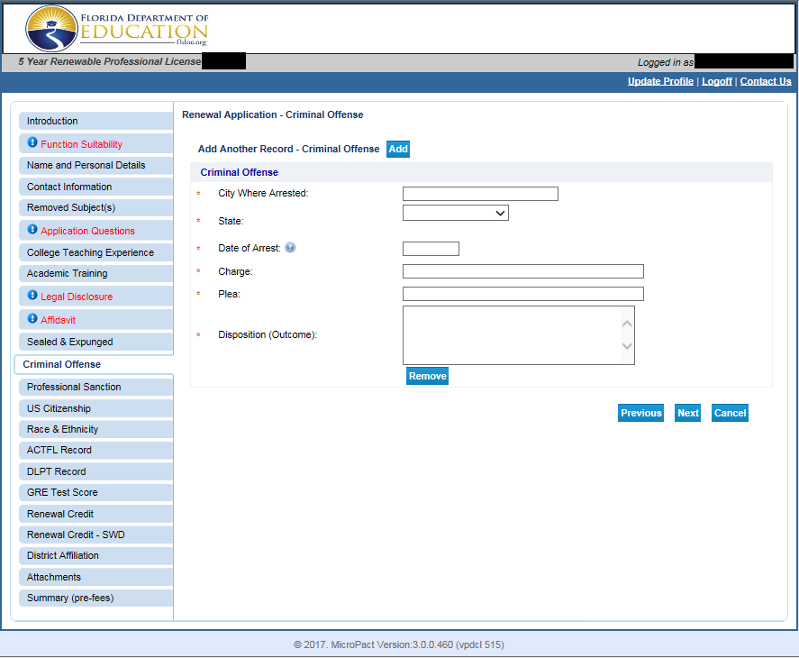
12. Criminal Offense
Carefully review instructions on the Legal Disclosure screen (see pages 9 and 10).
If you answered YES to any question in the Criminal Offense section of the Legal Disclosure on the application form: | If you answered NO to any question relating to Criminal Offense records:
You must provide detailed complete information for each affirmative response within the Criminal Offense section in this Legal Disclosure Supplement.  Click Add to enter a new record to display the fields above.  Enter information for all required fields.  Click Add to enter additional record(s).  Click Next to proceed to the next page. | Click Next to proceed to the next page.
 | If you click the “add” button in error:
Click Remove.

Click Ok to confirm that you want to delete the record, and then click Next to proceed to the next page.

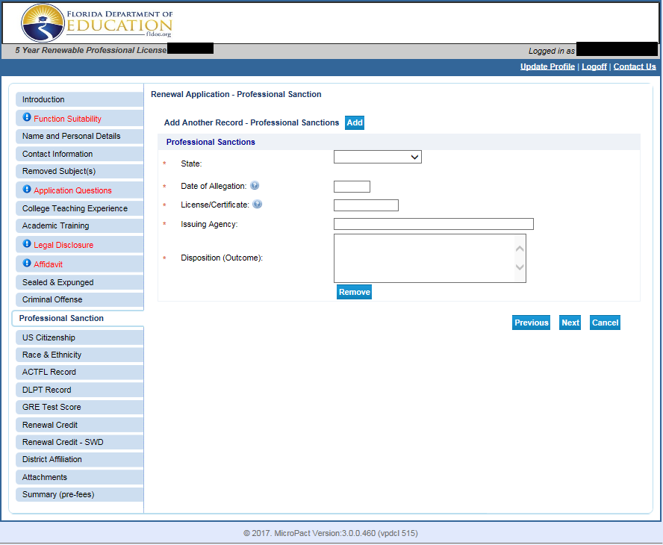
13. Professional Sanction
Carefully review instructions on the Legal Disclosure screen (see pages 9 and 10).
If you answered YES to any question in the Professional Sanction section of the Legal Disclosure on the application form: | If you answered NO to any question relating to Professional Sanction records:
You must provide detailed complete information for each affirmative response within the Professional Sanction section in this Legal Disclosure Supplement.  Click Add to enter a new record to display the fields above.  Enter information for all required fields.  Click Add to enter additional record(s).  Click Next to proceed to the next page. | Click Next to proceed to the next page.
 | If you click the “add” button in error:
Click Remove.

Click Ok to confirm that you want to delete the record, and then click Next to proceed to the next page.

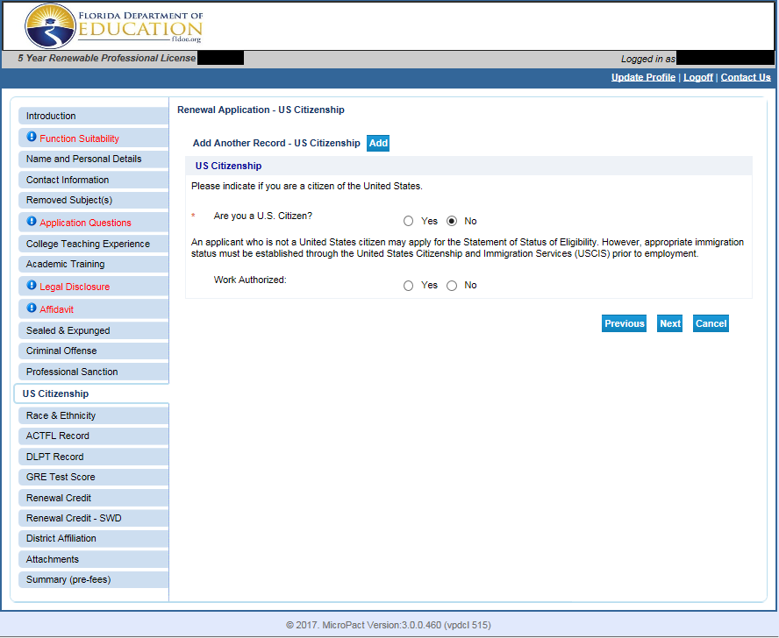
14. U.S. Citizenship
Indicate if you are a citizen of the United States. Select Yes or No.
If you are not a citizen of the United States, select Yes or No if you are authorized to work in the United States.
Click Next to proceed to the next page.

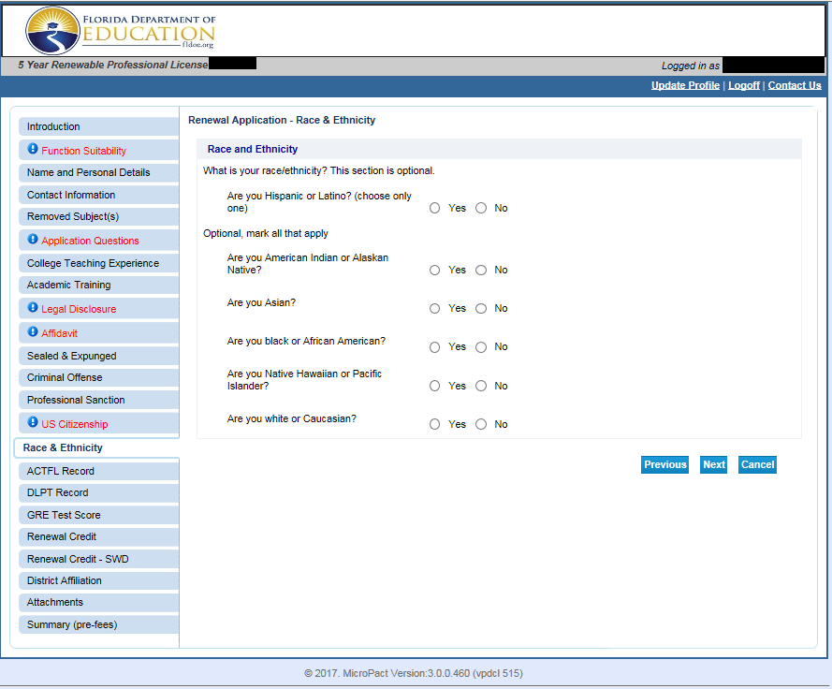
15. Race and Ethnicity- OPTIONAL
Respond Yes or No to the race and ethnicity questions.
Click Next to proceed to the next page.

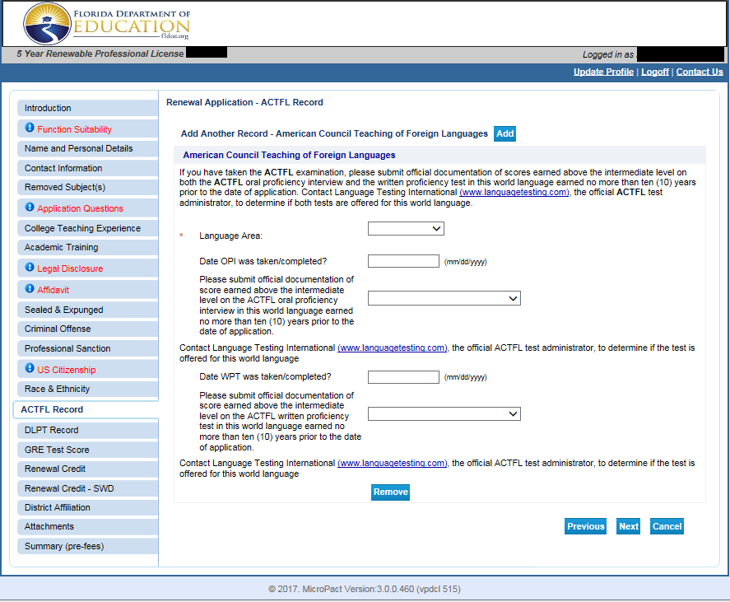
16. American Council Teaching of Foreign Languages
Note: Only applies to educators who hold select world language coverages on their professional certificate.
If you do not have ACTFL records: | If you have ACTFL records:
Click Next to proceed to the next page. | Information may be pre-populated based on official test scores.  If information is not pre-populated, click Add to enter a new record to display fields above.  Note: Record does not impact renewal of professional certificate.  Enter information for all fields.  Click Next to proceed to the next page.
If you click the “add” button in error:

Click Remove.

Click Ok to confirm that you want to delete the record, and then click Next to proceed to the next page.
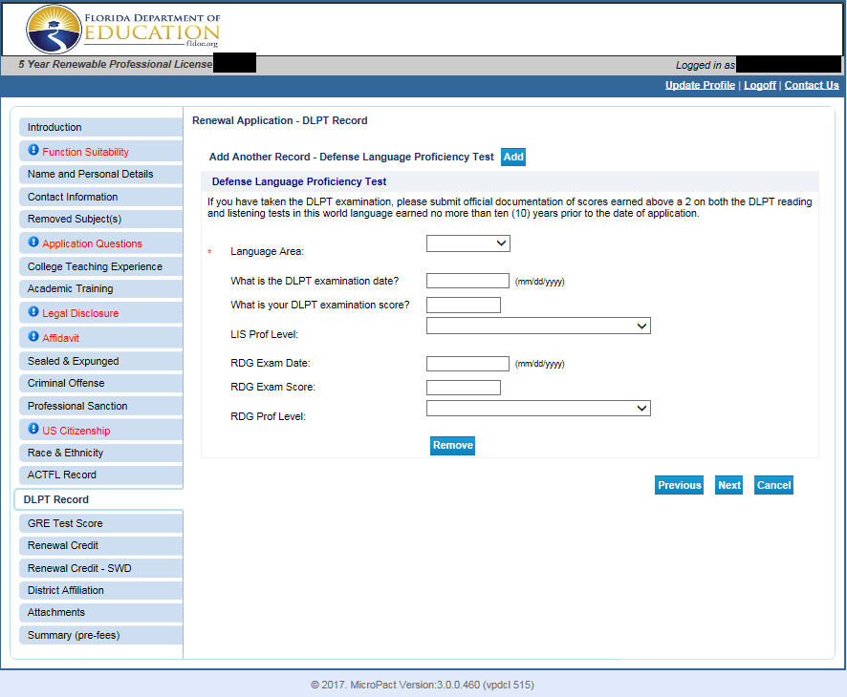
17. Defense Language Proficiency Test
Note: Only applies to educators who hold select world language coverages on their professional certificate and served in the military.
If you do not have DLPT records: | If you have DLPT records:
Click Next to proceed to the next page. | Information may be pre-populated based on official test scores.  If information is not pre-populated, click Add to enter a new record.  Note: Record does not impact renewal of professional certificate.  Enter information for all fields.  Click Next to proceed to the next page.
If you click the “add” button in error:
Click Remove.

Click Ok to confirm that you want to delete the record, and then click Next to proceed to the next page.

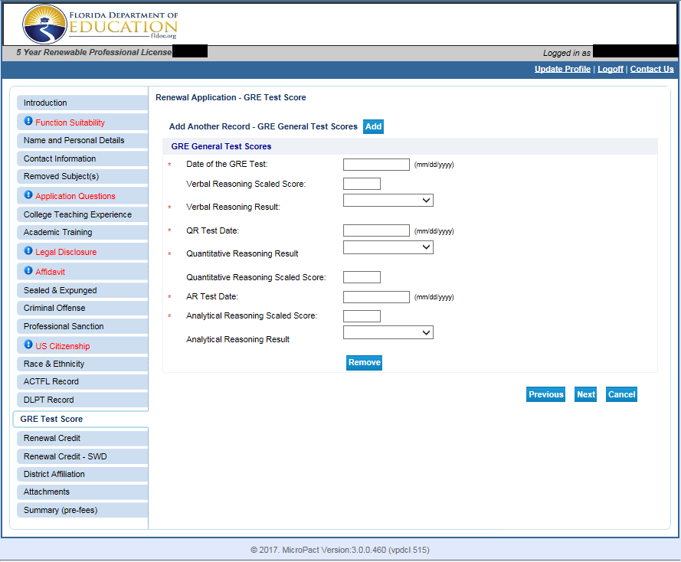
18. Graduate Record Examination (GRE) General Test Scores
Note: Only applies to educators who used GRE to satisfy the general knowledge requirement.
If you do not have GRE records: | If you have GRE records:
Click Next to proceed to the next page. | Information may be pre-populated based on official test scores.  If information is not pre-populated, click Add to enter a new record.  Note: Record does not impact renewal of professional certificate.  Enter information for all fields.  Click Next to proceed to the next page.
If you click the “add” button in error:
Click Remove.

Click Ok to confirm that you want to delete the record, and then click Next to proceed to the next page.
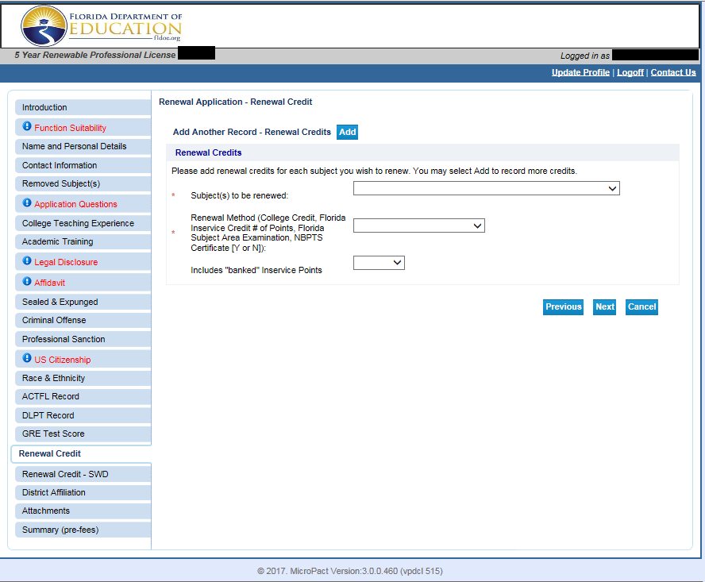
19. Renewal Credit
You must enter at least one record for renewal credit. All renewal credit records will be verified by district staff or BEC staff.
Click Add to enter a new record to display the fields above.
Enter the following required information:
- Select the subject to be renewed from the drop down menu.
- Select the renewal method for the subject to be renewed.
  - If you select inservice points, you will be asked to identify the inservice provider (district). If you district is not listed, select other.
Click Add to enter additional record(s) if you have multiple subjects.
Click Next to proceed to the next page.

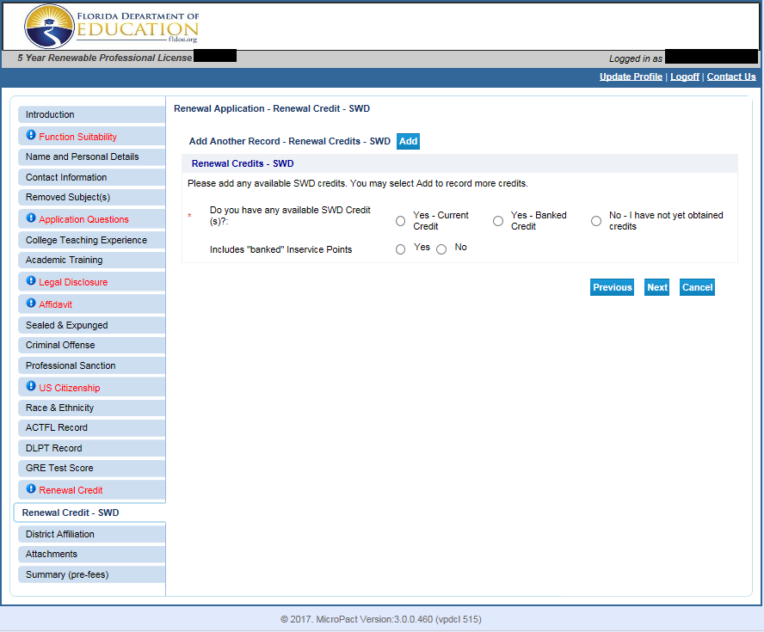
20. Renewal Credit SWD (Students With Disabilities)
You must enter at least one record for renewal credit for teaching Students with Disabilities (SWD). All renewal credit records will be verified by district staff or BEC staff.
Click Add to enter a new record to display the fields above.
Select the radio button for Yes- Current Credit or No- I have not yet obtained credits.
Note: Banked credit for SWD credit is not yet available.
Select the radio button for No for “includes banked inservice points”.
Click Add to enter additional record(s) if you have multiple subjects.
Click Next to proceed to the next page.

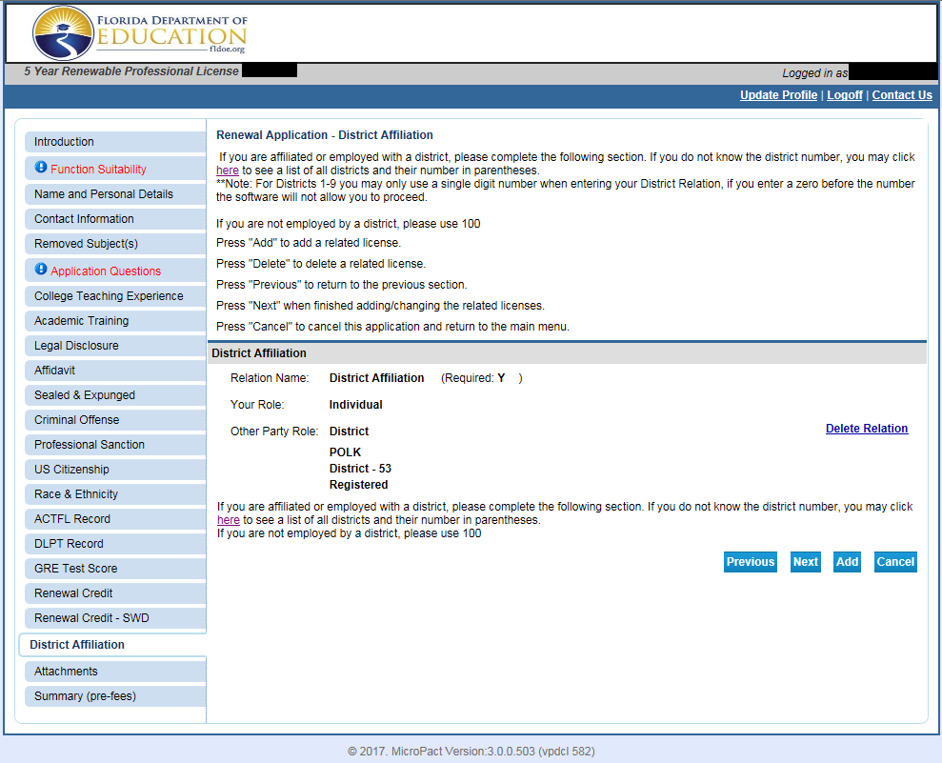
21. District Affiliation
IMPORTANT: PLEASE READ CAREFULLY. You may not have two affiliations or no affiliation.
If you work for a Florida School District (including charter schools): | If you are employed by a private school or if you are not employed by a Florida school district:
This screen displays the name and number of your employing school district. You will pay your district for your renewal.  1. If it is correct, click Next to proceed to the next page.  OR  2. If an incorrect affiliation displays, click on the Delete Relation link.  On the next screen, enter your district number and click Add. For districts, single digits for 1-9. If you do not know your district number, click on the link on the page.  You affiliation now displays as your current district.  Click Next to proceed to the next page. | Your affiliation needs to display as 100 in order to be processed properly by the Bureau of Educator Certification. You will pay online.  1. If it is correct, click Next to proceed to the next page.  OR  2. If an existing affiliation record displays, click on the Delete Relation link.  On the next screen, enter 100 and click Add.  You affiliation now displays as 100.  Click Next to proceed to the next page.

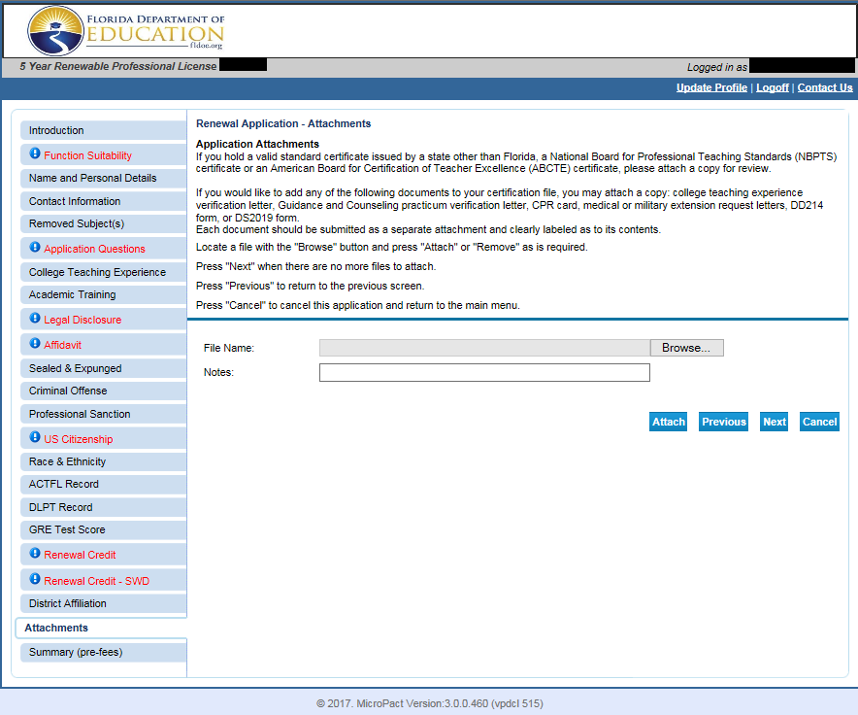
22. Attachments (OPTIONAL)
Please upload documents concerning your renewal application in this section.
Clearly label the type of document in the notes section.
Sample documents include, but are not limited to,:
- Legal Name Change Documents
- Copy of National Board Certificate
- College Teaching Experience Verification Letter

Do not attach official transcripts.

Click Next to proceed to the next page.
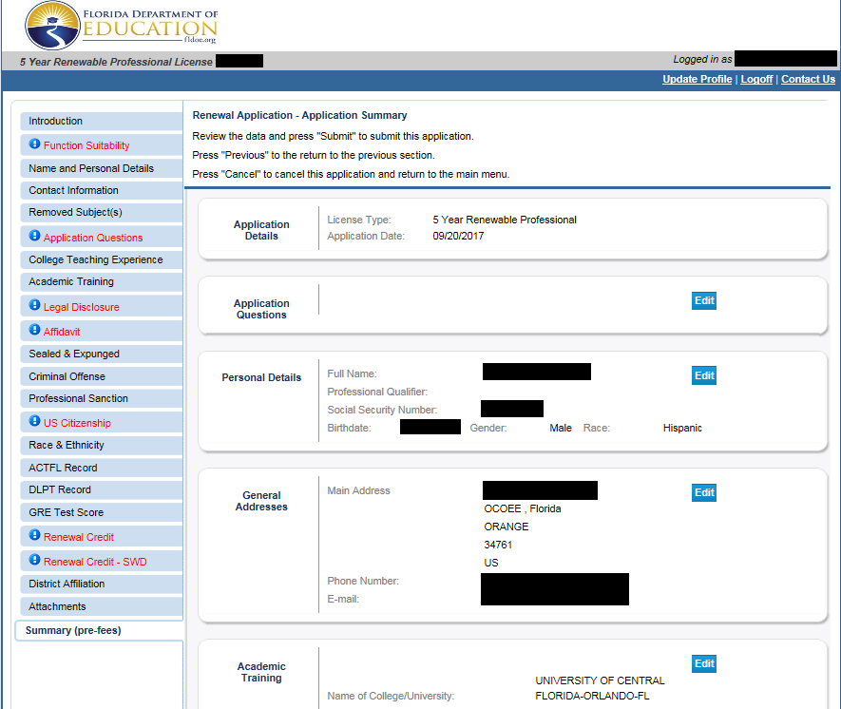
23. Summary (pre-fees)
Review your entries on the page.
Click edit if you need to make any changes prior to submitting your application.
Once you verify that all the information you entered is correct, click Submit at the bottom of the page.
You will be able to print a PDF summary of your application on the final screen (see page 26).

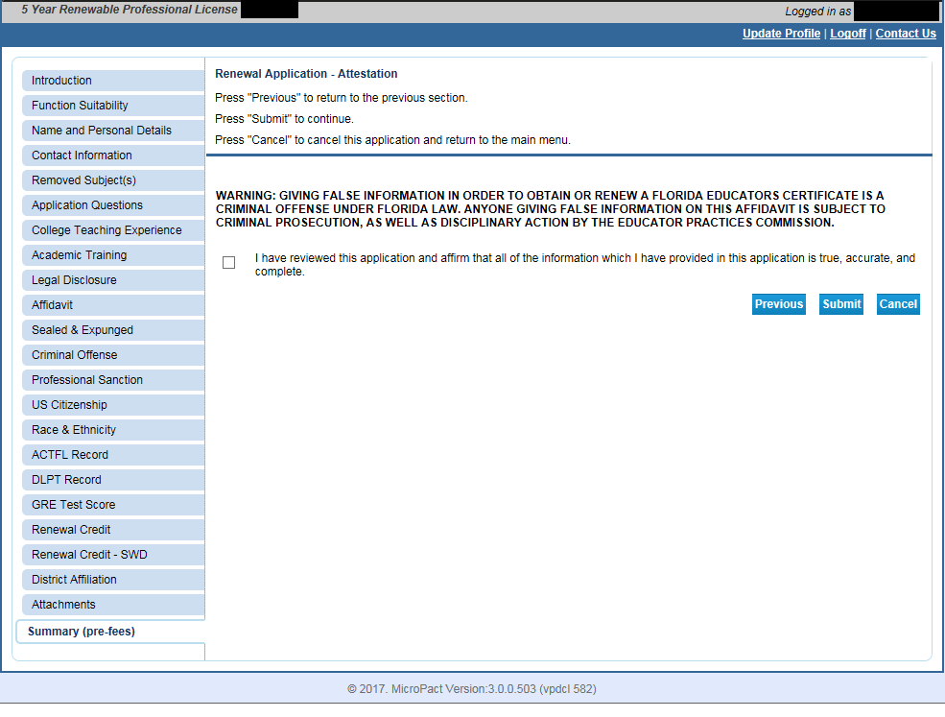
24. Renewal Application- Attestation
Click the checkbox to affirm that all of the information that you have provided in this application is true, accurate, and complete.
Warning: Giving false information in order to obtain or renew a Florida Educator’s Certificate is a criminal offense under Florida law. Anyone giving false information on this affidavit is subject to criminal prosecution, as well as disciplinary action by the Educator Practices Commission.
Click Submit to proceed to the final page.

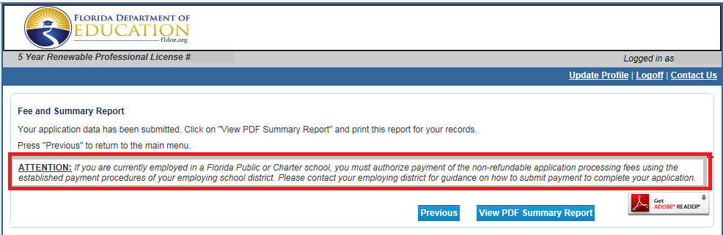
25. Fee and Summary Report
At this time you may print your PDF Summary Report.
A PDF Summary will be sent to the email address on file if you selected to receive email communication.
You may also view your PDF Summary on your Quick Start Menu documents section.
If you are employed by a school district: | If you are employed by a private school organization or no longer employed by a school district:
You will contact your employing school district for more information about their payment procedures.  You will pay $75.00 for a renewal submitted prior to the expiration date on your valid certificate. | You will submit online payment using a Visa or Mastercard for the total of $75.00 for a renewal submitted prior to the expiration date on your valid certificate.

